Individual Pathways
Activity 8.1
Revising forces, energy and motion

Useful formulas:
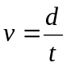 | 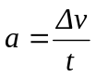 | F = ma
W = Fd | GPE = mgh | g = 9.8 m/s²

- Over a 1-minute period of time, the position of a coach was plotted as she moved along the sideline during a netball game. Her position at 5-second intervals is shown in the table below. Assume that the coach started at the midline of the court.

Time (s) | Position (m)
0 | 0
5 | 3
10 | 6
15 | 6
20 | 6
25 | 7
30 | 8
35 | 9
40 | 10
45 | 10
50 | 8
55 | 4
60 | 0

- Use the values in the table to draw a position-time graph of the coach’s motion over the 1-minute interval.

- What distance had the coach walked after 60 seconds? ………………………
- What was the coach’s displacement after 50 seconds? ………………………..
- Calculate her average speed between t = 0 and t = 10 s. Show your working.
................................................................................................................................................................................................................................................................................................................
- What was her average velocity over the 1-minute time interval? Explain your answer.
………………………………………………………………………………………………………………………………………………………………………………………………………….

- A hamster can cover 9 metres in 38 seconds. What is the speed of the hamster in m/s?
………………………………………………………………………………………………………………………………………………………………………………………………………………

- The ticker tape below shows the motion of a dynamics cart during an experiment. A ticker timer places 50 dots every second on the tape.

- What interval of time elapses between successive dots? …………………………………
- What period of time elapsed between points A and D? ………………………………

- In which intervals (A to B, B to C, or C to D) did the dynamics trolley:
- decelerate? Explain your answer. ………………………………………………………………………………………………………………………………………………………………………………………………
- remain at a constant speed? Explain your answer. …………………………………………………………………………….............................................................................................................................................................................

- What is the acceleration of a car that takes 8 seconds to reach a speed of 20 m/s if it starts from rest?
…………………………………………………………………………….......................................................................................................................................................................................................

- Complete the following table.
Force | Mass | Acceleration
100 N |  | 20 m/s²
 | 0.300 kg | 4 m/s²
1.2 N | 2 kg

- A car is travelling down the highway at a constant speed when a kangaroo bounces onto the road ahead. The driver takes his foot off the accelerator and brakes hard. In each of the following cases, explain whether the forces acting on the car are balanced or unbalanced.
- When the car is travelling at constant speed down the highway ………………………….
- When the car is decelerating …………………………..
- When the car has stopped ……………………………...

- Name and describe at least one of the safety features incorporated into a car’s design that prevents injury to the driver when:
- their car is rear-ended by another car
…………………………………………………………………………….........................................................................................................................................................................................
- their car hits a tree.
…………………………………………………………………………….........................................................................................................................................................................................

- State Newton’s Third Law of Motion.
…………………………………………………………………………….......................................................................................................................................................................................................

- During a bounce test on a squash ball, it is raised to a height of 120 cm and then dropped onto a smooth concrete floor. The height of the bounce is then measured.
State whether each of the following statements about the test is true or false.
- The ball has its maximum kinetic energy when it hits the concrete. ……………….
- While it is falling, the ball loses kinetic energy but gains gravitational potential energy.
- ………………
- The ball will bounce to a height of 120 cm. ………………
- When the ball strikes the concrete and compresses, kinetic energy is converted into elastic potential energy. ………………
- Some of the ball’s energy is destroyed every time it bounces. ………………
- Some of the kinetic energy of the ball is converted into heat when it strikes the ground.
………………

- Define what is meant by the term ‘work’.
………………………………………………………………………………………………………………………………………………………………………………………………………………

Answers

1.

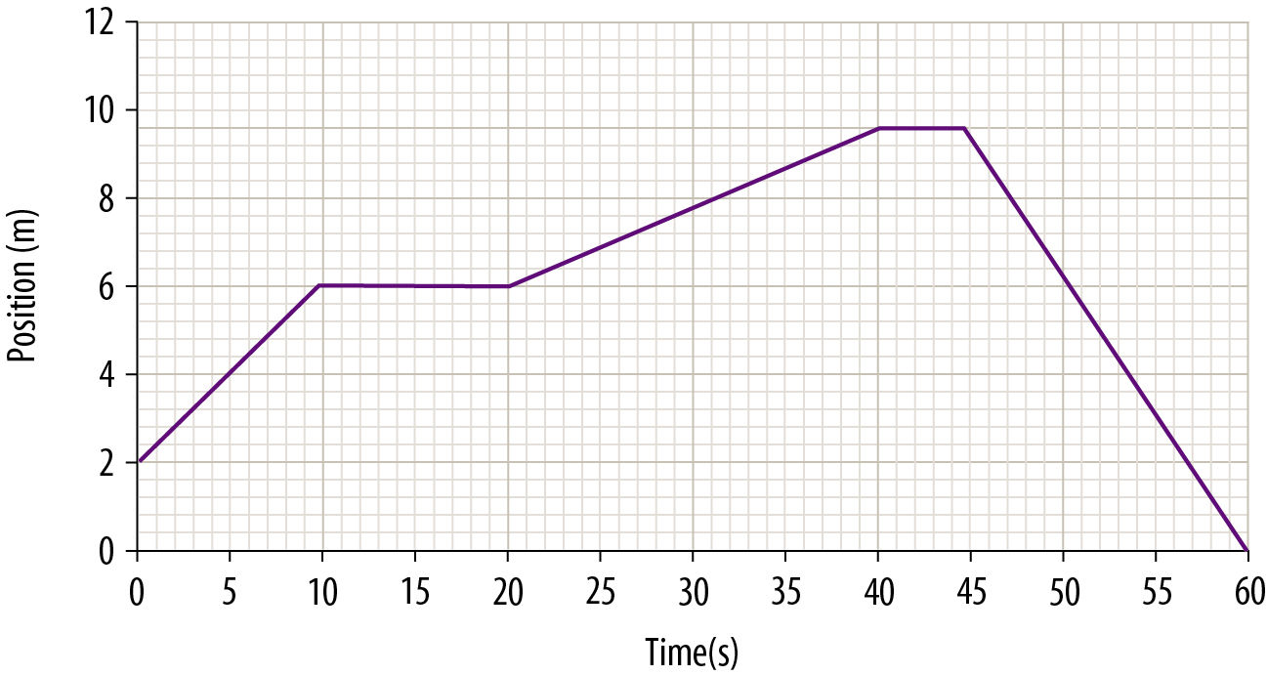
- 20 m
- 8 m
- 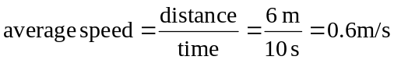
- 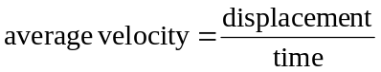
As the coach is back at her starting point at the end of the 1-minute interval, her displacement is 0 at that time. As a result, her average velocity will also be 0.

- 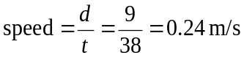
3.
- 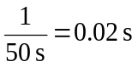
- 14 intervals × 0.02 s/interval = 0.28 s

- C to D: The distance between dots becomes progressively smaller, indicating that the speed of the trolley is decreasing.
- B to C: The distance between the dots remains uniform so the dynamics trolley would have been travelling at a constant speed.

- 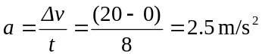

Force | Mass | Acceleration
100 N | 5 kg | 20 m/s²
1.2 N | 0.300 kg | 4 m/s²
1.2 N | 2 kg | 0.6 m/s²

- Balanced
- Unbalanced
- Balanced

- Possible responses include the following.
- Headrests prevent the driver’s head from moving backwards relative to the car as the car is shunted forwards.
- Crumple zones in the rear dissipate some of the energy of the collision.
- Possible responses include the following.
- Seatbelts and inflating airbags prevent the driver from continuing their forward motion.
- Deflating airbags increase the time taken for the driver to travel forward and decrease the impact force.
- Front crumple zones dissipate some of the energy of the collision.
- The padded console decreases impact force.

- When one object exerts a force on a second object, the second object exerts a force equal in size but opposite in direction on the first as a result (i.e. for every action, there is an equal and opposite reaction).

- True
- False
- False
- True
- False
- True

- Work is the product of the force applied to an object times the distance the object is moved in the direction of that force.

